**DOCUMENTATION**

**of**

##### PSYCHOPHYSIOLOGY SESSION PROCEDURES

**in**

**MIDUS 3**

**Neuroscience Project (P5)**

**University of Wisconsin ♦ Institute on Aging**

**March 2023**

**INTRODUCTION**

This document is intended to provide an overview of the Neuroscience Project’s (P5) MIDUS 3 psychophysiology data collection protocol and the measures collected during the session. Partial variable names have been provided where appropriate. For more detailed information on variable names and data collection procedures, please see (*M3_P5_VARIABLE_NAMES_20230331.docx* and *M3_P5_MEMO_README_20230331.docx*).

Sessions typically began late morning (between 11:30 a.m. and 12:00 p.m.), after completion of the Biomarker Project’s (P4) protocol at the UW Hospital (Madison, WI), and ended early evening (between 5:00 and 5:30 p.m.). Apart from a few questionnaires, whenever possible, all of the following measures were collected in the order listed below. In some cases, some data could not be provided due to time constraints during the day of the session, technical difficulties, or inability of participant to complete the task. In these cases, the appropriate missing value was listed (See *M3_P5_MEMO_README_20230331.docx* and *M3_P5_DOCUMENTATION_OF_SCALES_20230331.docx* for further information on missing values).

Data collection was halted after March 2020 due to the COVID-19 pandemic. Data collection resumed October 2020, before vaccines were widely available, with new COVID protocols in place. Variables C5PDATE_YR and C5PDATE_MO can be used to determine if a participant completed our protocol before or during the COVID-19 pandemic. New COVID protocols included a temperature check and screening questions before data collection started, the use of medical-grade face masks, application of disposable facial sensors (participants would briefly remove their masks for this application), the use of a portable air purifier running in our data collection rooms and extensive sanitation procedures. To increase air flow, we would utilize separate rooms for sensor application, data collection, and cognitive testing/questionnaires when able. Please see (*M3_P5_INSTRUMENTS_20230331.docx and M3_P5_MEMO_README_20230331.docx)* for more information.

**Neuroscience Project (P5) Psychophysiology Protocol & Variable Naming**

1. **Questionnaires completed before the psychophysiology task:**
   1. State-Trait Anxiety Inventory – State Form (STAI-X1), TIME 1 **[C5SS1]**
   2. Positive Affect Negative Affect Schedule-Now, TIME 1 **[C5SP1]**

Further information regarding questionnaires can be found in: *M3_P5_DOCUMENTATION_OF_SCALES_20230331.docx*

1. **Hearing Test** **[C5O]:** Tones of various frequencies (250, 500, 1000, 2000, 4000 Hz) were played for participants in one ear at a time. Participants indicated when they were able to hear a tone. Data represents the lowest decibel level at which participants were able to hear a tone at a particular frequency in each ear. NOTE: Frequencies 2000 and 4000 were added part way through the study so they are not available for all participants.
2. **Psychophysiology Task:**
   1. Physiocheck – tests physiological signals
   2. Practice trials
   3. Baseline – five-minute recording while participant is at rest
   4. Emotional response task with border identification response times and accuracy (4 blocks ~7 ½ minutes each):
      1. Corrugator EMG **[C5C]**
      2. Eyeblink startle reflex (EBR) **[C5B]**
      3. Zygomaticus EMG **[C5L]**

*Sensor Application:* Facial EMG sensors were applied to the corrugator supercilii, zygomaticus major, and orbicularis oculi, as shown in the figure below. Disposable sensors replaced these non-disposable sensors in October 2020. A description of the different sensor types can be found in (*M3_P5_INSTRUMENTS_20230331).*

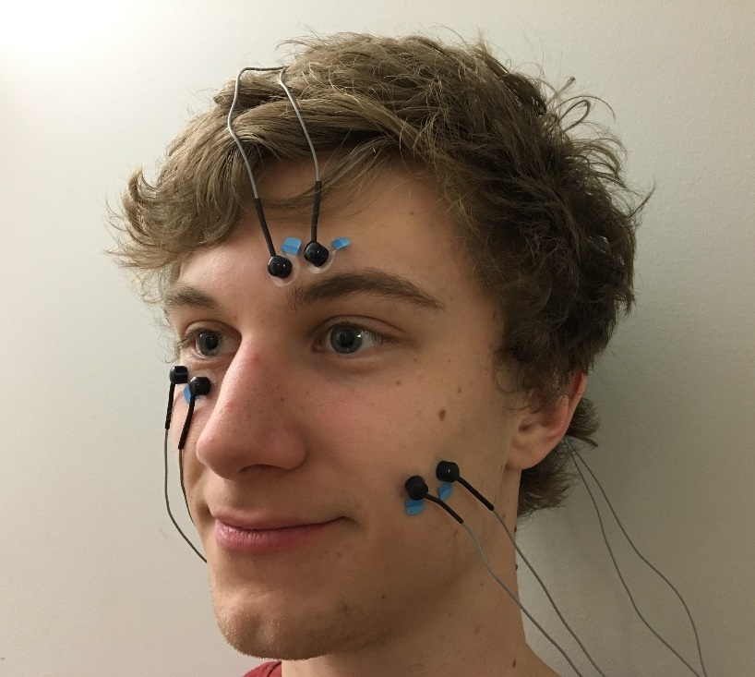

*MIDUS3 Psychophysiology Task Schema:*

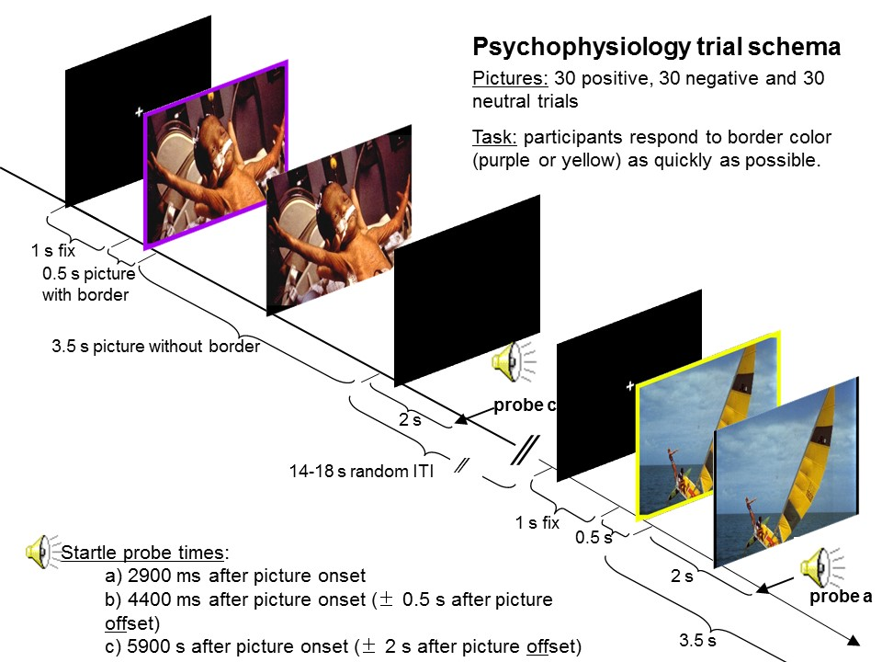

Further information regarding the Psychophysiology task can be found in:

*M3_P5_INSTRUMENTS_20230331.docx*

1. **Questionnaires completed after the psychophysiology task:**
   1. STAI-X1, TIME 2 **[C5SS2]**
   2. PANAS-NOW, TIME 2 **[C5SP2]**
   3. Cube and Paper Task **[C5D]**

Further information regarding questionnaires can be found in: *M3_P5_DOCUMENTATION_OF_SCALES_20230331.docx*

1. **Other questionnaires (not completed at a specific time)**
   1. State-Trait Anxiety Inventory – Trait Form (STAI-X2) **[C5SST]**
   2. Positive Affect Negative Affect Schedule-General **[C5SPG]**
   3. Dispositional Positive Emotion Scale (DPES) **[C5SDP]**
   4. Emotion Regulation Questionnaire **[C5SER]**
   5. Interpersonal Reactivity Index (IRI) **[C5SIR]**

Further information regarding questionnaires can be found in: *M3_P5_DOCUMENTATION_OF_SCALES_20230331.docx*

* 1. **6. CANTAB**
  2. Motor Screening Test (MOT) **[C5NM]**
  3. Intra-Extra Dimensional Set Shift (IED) **[C5NI]**
  4. Affective Go/No-go (AGN) **[C5NA]**
  5. Information Sampling Test (IST)**[C5NS]**
  6. Attention Switching Task (AST) **[C5NT]**
  7. Emotion Recognition Task (ERT) **[C5NE]**
  8. Cambridge Gambling Task (CGT) **[C5NG]** *
     1. *Note that CGT data is typically collected on the second day of participation in the neuroscience project (i.e., the day of the MRI scan).

Further information regarding CANTAB tasks can be found in:

*M3_P5_DOCUMENTATION_OF_CANTAB_20230331.docx*

1. **Free Recall** **[C5F]**

For the free recall task, participants were given *up to* 15 minutes to recall as many of the pictures seen during the psychophysiology task as possible by writing descriptions onto a blank sheet of paper. Written descriptions were carefully matched to the appropriate picture. Data are given as total number of pictures correctly recalled by valence, by social and nonsocial picture types, and overall. NOTE: Due to scheduling conflicts some participants completed the MRI scan prior to the psychophysiology session. In those cases, participants free recall scores may include images from both the MRI and psychophysiology picture sets. A variable has been included to indicate if the scan was completed prior to free recall **[C5FM]**.

**7. Picture Ratings Task**

* 1. Valence (Unpleasant vs. Pleasant) **[C5TV]**

Participants rated the images viewed during the psychophysiology task by valence on a scale of 1-9 using Bradley and Lang’s Self-Assessment Manikin (1994):

PLEASANT

UNPLEASANT

**1 2 3 4 5 6 7 8 9**

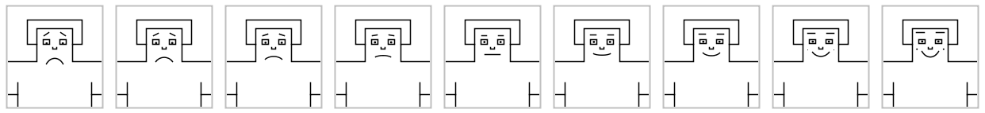

* 1. Arousal (Calm vs. Excited) **[C5TA]**

Participants rated the images viewed during the psychophysiology task by arousal on a scale of 1-9:

EXCITED

CALM

**1 2 3 4 5 6 7 8 9**

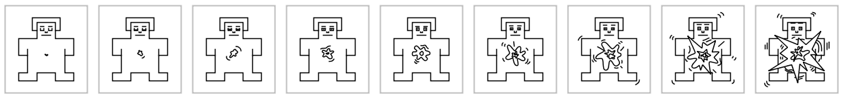

Mean ratings of valence and arousal are provided for each category of picture valence (positive, negative, and neutral).

**REFERENCES**

Bradley, M. M., & Lang, P. J. (1994). Measuring emotion: the self-assessment manikin and the semantic differential. *Journal of Behavior Therapy and Experimental Psychiatry*, *25*(1), 49–59.